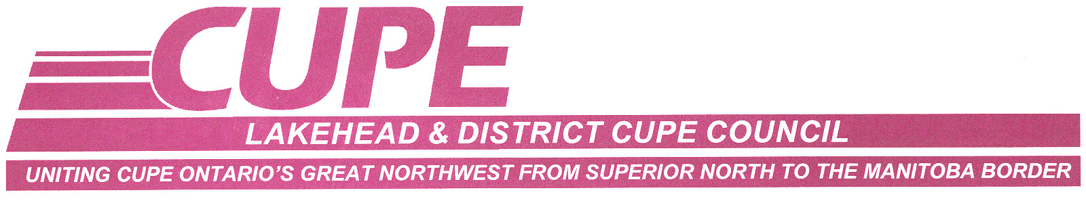

Per Capita for the Month of ________________

Date: _____________________

LOCAL: ___________________ Contact Person: _________________

Full Time Members: __________ @ $0.30

Part-Time Members: __________ @ $0.15

TOTAL AMOUNT: $__________

Please make cheques payable to: Lakehead and District CUPE Council

Submit to: Patti Halstead, Treasurer
Lakehead and District CUPE Council
522 First St.W.
Fort Frances, Ontario
P9A 2Y5

